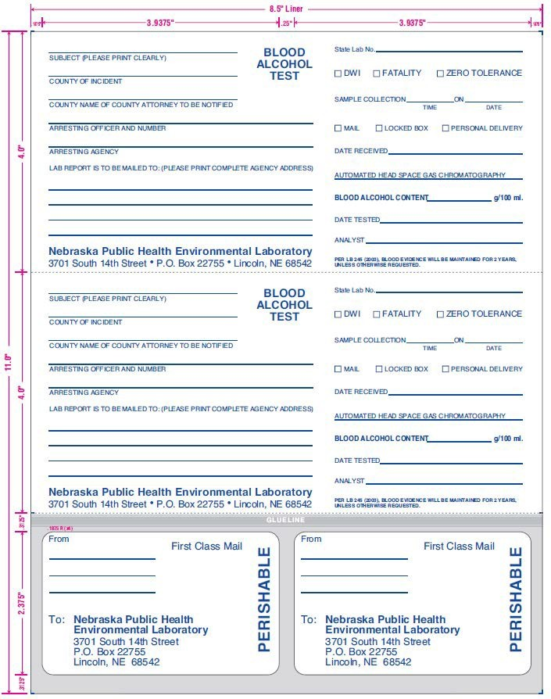

ATTACHMENT A

Alcohol Laboratory Request Forms

